**Biden to nominate** Janet Yellen as US treasury secretary

Published

1 hour ago

Share

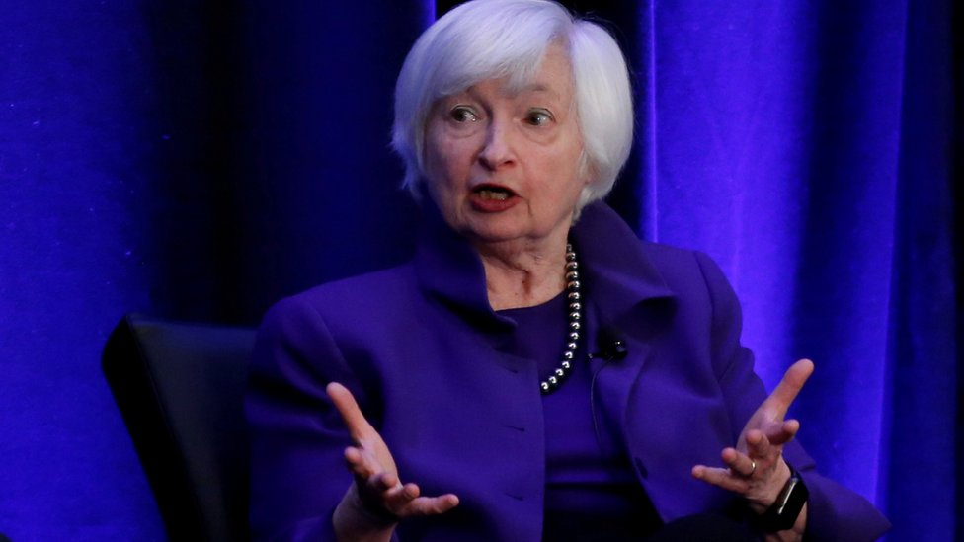IMAGE COPYRIGHTREUTERS

image captionJanet Yellen's appointment needs to be confirmed by the Senate

**US President-elect Joe Biden has named ex-Federal Reserve chair Janet Yellen as his nominee for treasury secretary.**

If confirmed by the Senate, she would be the first woman ever to hold the post.

She was among several women chosen for top economic positions. The Biden transition team said others were set to break racial barriers if confirmed.

Mr Biden has pledged to build a diverse administration. He earlier appointed an all-female senior press team.

Mr Biden's transition team said his picks for senior economic roles would help "lift America out of the current economic downturn and build back better".

Mr Biden has also announced the formation of a Presidential Inaugural Committee ahead of his swearing-in on 20 January. The committee will be responsible for organising inauguration-related activities.

Who is Janet Yellen?

Ms Yellen had been [**widely tipped for the nomination in media reports prior to Monday's announcement.**](https://www.bbc.co.uk/news/business-55051511)

The 74-year-old economist has served as head of America's central bank and as a top economics adviser to former President Bill Clinton.

She is credited with helping steer the economic recovery after the 2007 financial crisis and ensuing recession.

As chair of the US Federal Reserve, Ms Yellen was known for focusing more attention on the impact of the bank's policies on workers and the costs of America's rising inequality.

Donald Trump bucked Washington tradition when he opted not to appoint Ms Yellen to a second four-year term at the Fed. Starting with Bill Clinton in the 1990s, presidents kept on bank leaders appointed by their predecessors in an effort to de-politicise the bank.

Since leaving the bank in 2018, Ms Yellen has spoken out about climate change and the need for Washington to do more to shield the US economy from the impact of the coronavirus pandemic.

In a tweet following Monday's announcement, Ms Yellen said: "We face great challenges as a country right now. To recover, we must restore the American dream - a society where each person can rise to their potential and dream even bigger for their children.

"As Treasury Secretary, I will work every day towards rebuilding that dream for all."